**Engineering Exploration**

(ASE-101)



PROJECT REPORT

BATCH-2018

**Section 4P, Group No. 2 (Team Tech Ninjas)**

**Hritvik Maini: 1811981145 Ms. Lipika ____________**

**Vaibhav Haswani: 1811981335 Dr. Ashok ____________**

**Piyush Kapil: 1811981234 Dr. Arun ___________**

**Suryansh Goel: 1811982008 Dr. Madhu ___________**

**Need Statement Issued to the group:-**

To develop an arduino and GPS (Global positioning system) based device for the University buses so that students and teachers can track their buses any time by visiting website.

**GANTT CHART: PROJECT TIMELINE**

|  |  |  |  |  |  |  |  |  |  |  |  |  |  |
| --- | --- | --- | --- | --- | --- | --- | --- | --- | --- | --- | --- | --- | --- |
|  | **Weeks** | **1** | **2** | **3** | **4** | **5** | **6** | **7** | **8** | **9** | **10** | **11** | **12** |
| **Stage 1** | **Need statement** | ✓ |  |  |  |  |  |  |  |  |  |  |  |
| **Stage 2** | **OFC** |  | ✓ |  |  |  |  |  |  |  |  |  |  |
| **Stage 3** | **Problem statement** |  |  | ✓ |  |  |  |  |  |  |  |  |  |
| **Stage 4** | **OFC Analysis** |  |  |  | ✓ |  |  |  |  |  |  |  |  |
| **Stage 5** | **Identifying multiple solution** |  |  |  |  | ✓ |  |  |  |  |  |  |  |
| **Stage 6** | **Choosing the best solution** |  |  |  |  |  | ✓ |  |  |  |  |  |  |
| **Stage 7** | **Conceptual Design and optimization** |  |  |  |  |  |  | ✓ | ✓ |  |  |  |  |
| **Stage 8** | **Prototyping** |  |  |  |  |  |  |  | ✓ | ✓ | ✓ | ✓ |  |
| **Stage 9** | **Testing** |  |  |  |  |  |  |  |  |  | ✓ | ✓ |  |
| **Stage 10** | **Documentation** |  |  |  |  |  |  |  |  |  |  |  | ✓ |

**Objective-Function-Constraint Identification (Tick)**

|  |  |  |  |
| --- | --- | --- | --- |
| **Characteristics** | **Objective** | **Constrains** | **Functions** |
| Accurate Navigation | ✓ |  |  |
| Easy To Use | ✓ |  |  |
| Acquire Less Space |  | ✓ |  |
| Free Of Cost | ✓ |  |  |
| Excellent GUI Of Website |  | ✓ |  |
| Bugs Free Website | ✓ |  |  |
| Compactable With All Versions Of Browsers |  |  | ✓ |
| LCD Display |  |  | ✓ |
| Shows Actual Position Of Bus |  |  | ✓ |

**Problem Statement of the group:-**

To develop an arduino and GPS (Global positioning system) based device for the University buses so that students and teachers can track their buses any time by visiting website.

**Pair-Wise Comparison Charts**

**PCC Chart-By Hritvik**

|  |  |  |  |  |
| --- | --- | --- | --- | --- |
| **Objectives** | Accurate Navigation | Easy To Use | Free Of Cost | Bugs Free Website |
| Accurate Navigation | ---- | 1 | 1 | 1 |
| Easy To Use | 0 | ---- | 1 | 0 |
| Free Of Cost | 0 | 1 | ---- | 0 |
| Bugs Free Website | 0 | 1 | 1 | ---- |

**PCC Chart-By Suryansh**

|  |  |  |  |  |
| --- | --- | --- | --- | --- |
| **Objectives** | Accurate Navigation | Easy To Use | Free Of Cost | Bugs Free Website |
| Accurate Navigation | ---- | 1 | 0 | 0 |
| Easy To Use | 1 | ---- | 0 | 0 |
| Free Of Cost | 0 | 1 | ---- | 0 |
| Bugs Free Website | 1 | 1 | 0 | ---- |

**PCC Chart-By Piyush**

|  |  |  |  |  |
| --- | --- | --- | --- | --- |
| **Objectives** | Accurate Navigation | Easy To Use | Free Of Cost | Bugs Free Website |
| Accurate Navigation | ---- | 0 | 0 | 1 |
| Easy To Use | 0 | ---- | 1 | 0 |
| Free Of Cost | 1 | 0 | ---- | 0 |
| Bugs Free Website | 0 | 1 | 1 | ---- |

**PCC Chart-By Vaibhav**

|  |  |  |  |  |
| --- | --- | --- | --- | --- |
| **Objectives** | Accurate Navigation | Easy To Use | Free Of Cost | Bugs Free Website |
| Accurate Navigation | ---- | 0 | 1 | 0 |
| Easy To Use | 1 | ---- | 1 | 0 |
| Free Of Cost | 0 | 0 | ---- | 1 |
| Bugs Free Website | 1 | 1 | 0 | ---- |

**Final PCC Evaluation**

|  |  |  |  |  |
| --- | --- | --- | --- | --- |
| **Objectives** | Accurate Navigation | Easy To Use | Free Of Cost | Bugs Free Website |
| Accurate Navigation | ---- | 2 | 2 | 2 |
| Easy To Use | 2 | ---- | 3 | 0 |
| Free Of Cost | 1 | 2 | ---- | 1 |
| Bugs Free Website | 2 | 4 | 2 | ---- |

**Ranking of Objectives**

|  |  |  |
| --- | --- | --- |
| **Objectives** | Total Score | Rank |
| Accurate Navigation | 10 | 2 |
| Easy To Use | 9 | 3 |
| Free Of Cost | 8 | 4 |
| Bugs Free Website | 12 | 1 |

**Constraint Analysis Chart**

|  |  |
| --- | --- |
| **Constraints** | **Limits** |
| Acquire Less Space | Requires Less Space But The Box (Made Of Wood) May Be Heavy  &  Proper Cooling System Must Be Provided In Order To Avoid Heat Accumulation In The Box |
| Excellent GUI Of Website | Requires Full Knowledge About HTML (V5)  &  A Lot Of Time Is Required To Write Code And Then To Find Bugs |

**Morphological Chart**

|  |  |  |  |
| --- | --- | --- | --- |
| **Functions** | **Sub-functions** | **Means** | |
| Compactable With All Versions Of Browsers | Support Every Version Of Web Browser Including Chrome, Firefox,  Safari etc.. | Using  HTML 1.0  HTML 2.0  HTML 3.0 | Using  HTML 4.01  XHTML 1.0  &  HTML 5  (Latest Release) |
| LCD Display | Displays Wi-Fi & GPS Status, IP Address, Lat. & Long. | Using 2x16 LCD Display | Using 4x20 LCD Display |
| Shows Actual Position Of Bus | Map Shows Actual Position Of Bus By Placing A Red Marker On It | NEO-6M GPS Module | Google Maps |

**Generating Multiple Concepts**

|  |  |
| --- | --- |
| **Mu Multiple Concepts** | **Concept Color** |
| Concept-1 | RED |
| Concept-2 | Blue |

**Analysis of Multiple Concepts Generated**

|  |  |  |  |
| --- | --- | --- | --- |
| **Criteria** | | **Concept-1** | **Concept-2** |
| **Objectives** | Accurate Navigation | **X** | **✓** |
| Easy To Use | **X** | ✓ |
| Free Of Cost | ✓ | ✓ |
| Bugs Free Website | **X** | **X** |
| **Constraints** | Acquire Less Space | ✓ | ✓ |
| Excellent GUI Of Website | **X** | ✓ |

**Final Design Decision: Pugh Chart**

|  |  |  |  |
| --- | --- | --- | --- |
| **Objectives** | **Weightage**  **(1-10)** | **Concept-1** | **Concept-2** |
| Accurate Navigation | **9** | **0** | **9** |
| Easy To Use | **6** | **0** | **6** |
| Free Of Cost | **4** | **4** | **4** |
| Bugs Free Website | **8** | **0** | **0** |
| **Final Score** | | **4** | **19** |

**Black Box Diagram**

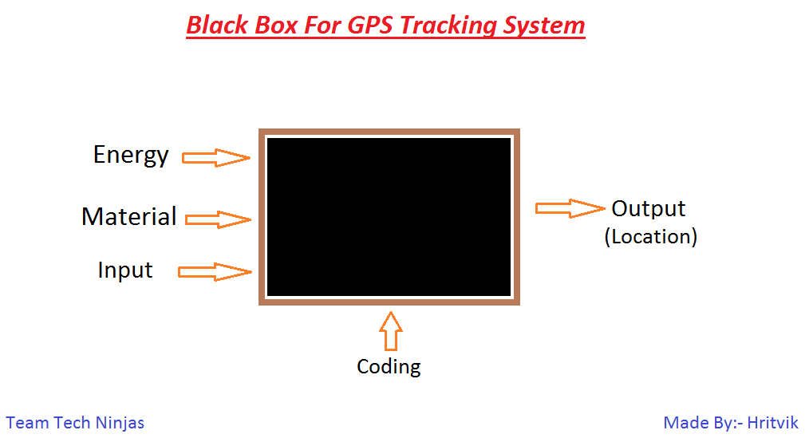

**Transparent box diagram**

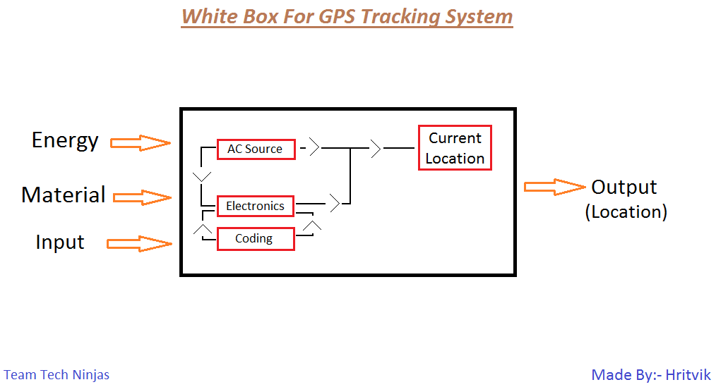

**Conceptual Design**

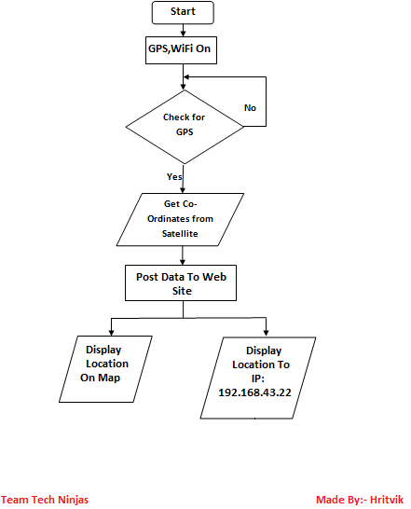

**PROTOTYPE PHOTOGRAPHS**

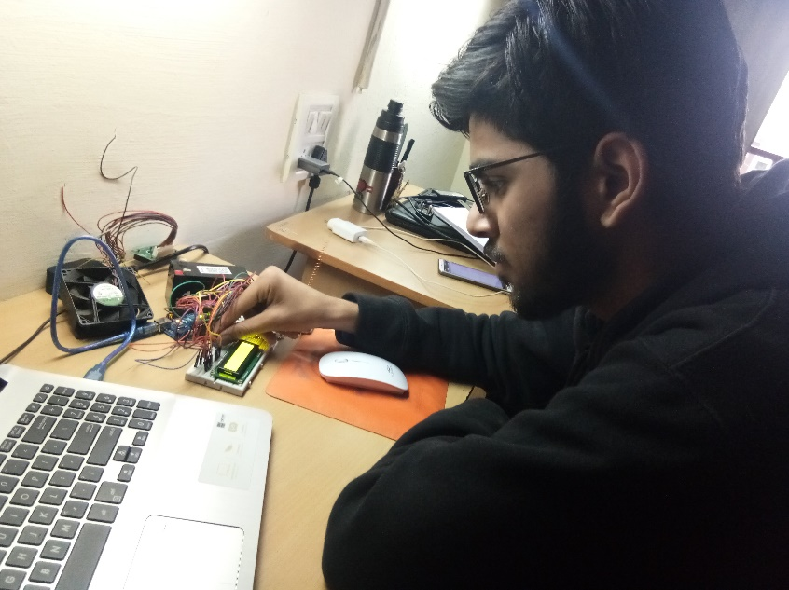

**Assembling**

**@ Workshop**

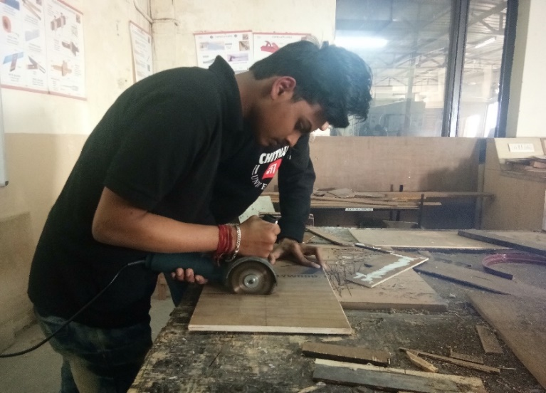

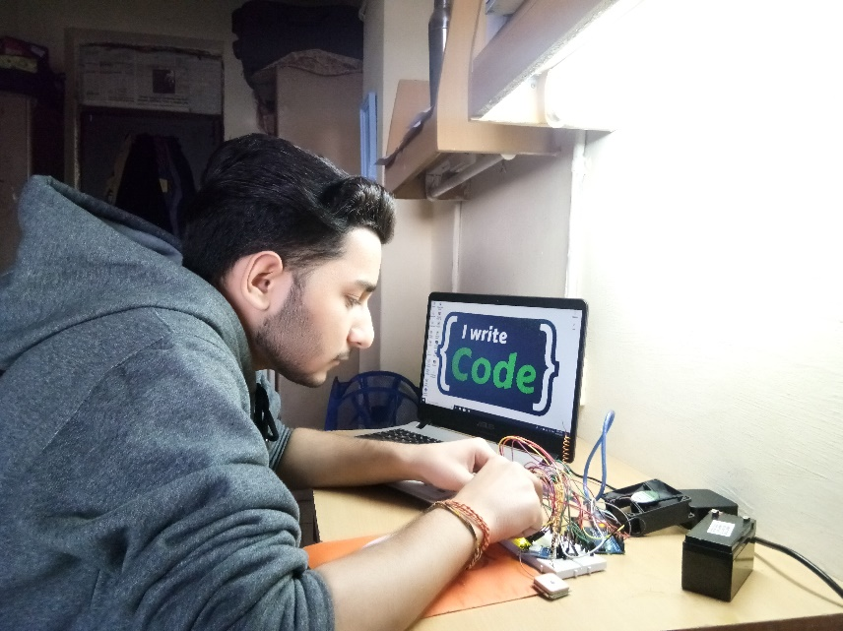

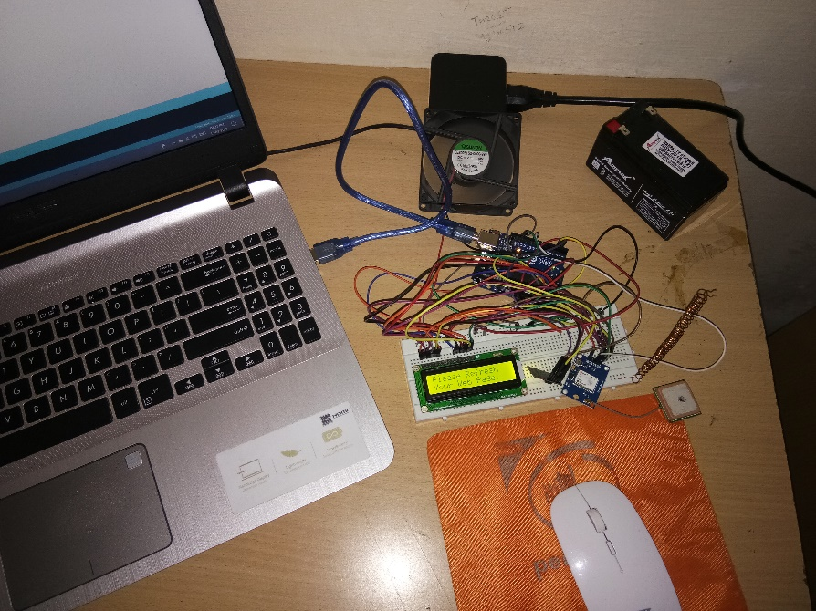

**Coding**

**TEAM FORMING CHART**

|  |  |  |  |  |
| --- | --- | --- | --- | --- |
| **S. No.** | **Name of the students** | **ID** | **Role** | **Responsibility** |
| **1** | Hritvik | 1811981145 | Coding | Assembling  &  Coding |
| **2** | Piyush | 1811981234 | Outer Structure | Making Box Of Wood For Holding Components |
| **3** | Vaibhav | 1811981335 | Website | Making Website For User Interface |
| **4** | Suryansh | 1811982008 | Outer Structure | Dimensions Of Box, Components & Wiring |

**TEAM STORMING CHART**

|  |  |  |  |
| --- | --- | --- | --- |
| **Meeting no.** | **Date** | **Attendance** | **Topic discussed/Problem** |
| 1 | 20/9/18 | All Present | How To Make Project,  Coding & Structure |
| 2 | 25/10/18 | All Present | Completion Of All Type Of Charts |
| 3 | 17/1/19 | All Present | Working On Arduino |
| 4 | 14/2/19 | All Present | Coding & Outer Structure Of GPS |
| 5 | 7/3/19 | All Present | Making Of Outer Box & Comp. Of Project |

**Bill Of Materials**

|  |  |  |  |  |  |
| --- | --- | --- | --- | --- | --- |
| **Student Names**  **Hritvik**  **Vaibhav**  **Suryansh**  **Piyush** | | | **ID**  **1811981145**  **1811981335**  **1811982008**  **1811981234** | | |
| **Problem Statement**  To develop an arduino and GPS (Global positioning system) based device for the University buses so that students and teachers can track their buses any time by visiting website. | | | | | |
| **S.No.** | **Item Name** | **Specification** | **No. Of item required** | **Cost per piece** | **Total cost** |
| 1. | Jumpers | Connecting Wires | 30 | 2 | 60 |
| 2. | ESP-8266 | Wi-Fi Module | 1 | 170 | 170 |
| 3. | NEO-6M  Module | GPS Module | 1 | 650 | 650 |
| 4. | 16x2 LCD  Display | LCD Display | 1 | 120 | 120 |
| 5. | Arduino Uno | Arduino | 1 | 500 | 500 |
| 6. | 12v Battery | Battery | 1 | 420 | 420 |
| 7. | 12v DC Adapter | Charger | 1 | 280 | 280 |
| 8. | Sim900A  Modules | Sim Modules | 2 | 1150 | 2300 |
| Grand Total:- | | | | | 4500 |

**Signature of Supervisor**

**FAILURE ANALYSIS**

1. Unable To Add (SIM900A) GSM Module, As Both Times It Short Circuited When We Trying To Add In Our Project.
2. Due To Above Reason We Are Not In Condition To Make An Android App To Directly Access Web Page.

Team Tech Ninjas

Hritvik, Piyush, Vaibhav, Suryansh